**A LEVEL MATHS  
Virtual Induction Day 2021**

Hey! Welcome to the A Level Maths Taster Session which will give you all the information you need along with a flavour of what studying A Level Maths at TCOLC is like.

In this folder, as well as this file, you will find these files:

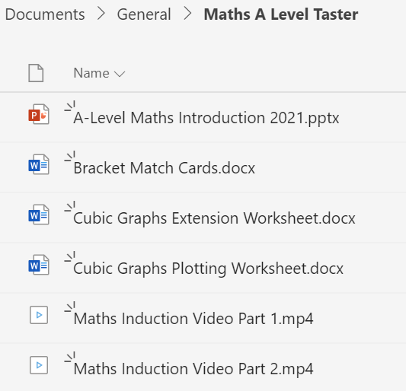

There are two video files for you to watch:

* Part 1 is an introduction to the course with all the details required.
  + The PowerPoint for this video is also included in this folder in case you want to print out any of the information…
* Part 2 is a taster lesson on Cubics and their graphs.
  + For the lesson there are three files that you could print out before watching the   
    Part 2 video. These are:
    - Bracket Match Cards – even better if you cut them out too!
    - Cubic Graphs Plotting Worksheet
    - Cubic Graphs Extension Worksheet – this extra worksheet delves deeper into cubic graphs…

The Year 11 to Year 12 Transition Work will be available through the TCOLC website, details to follow!

If you have any further questions please get in touch:

[ylarge@cityleicester.leicester.sch.uk](mailto:ylarge@cityleicester.leicester.sch.uk)

[nislam1@cityleicester.leicester.sch.uk](mailto:nislam1@cityleicester.leicester.sch.uk)

We look forward to seeing you in September!!!