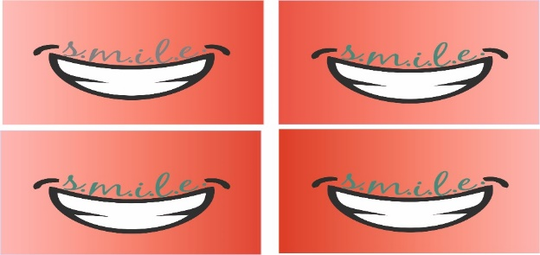

2020-2021



Yr11 – 12 Transition Activities

Subject: Chemistry

The City of Leicester College

**Contents**

**Part One - Using maths in chemistry page 2**

Standard form and Significant figures

Converting Units

Measuring chemicals – the mole

Measuring chemicals - Solutions and concentration

**Part Two - Skills for Practical Chemistry page 9**

Drawing tables

Task for submission

**Part Three – Research Activities page 12**

Cornell notes and Referencing

Task for submission

**Part four - Minimising Risk page 15**

Risk Assessment

Task for submission

**Part One – Using maths in chemistry**

The first section of this booklet focuses on some of the mathematical application of A level Chemistry. You will be expected to rearrange equations, convert between units, use standard form and report data to an appropriate number of significant figures. There is a section for each of these skills below.

**Standard form and Significant figures**

In the calculations you will be asked to perform as part of your A level studies you will need to be confident with both representing numbers in standard form and giving them to a certain number of significant figures.

When numbers are very large or very small they are written in **standard form**. In standard form a number is written in the format;

*a* × 10*n* where 1 ≤ *a* < 10 and *n* is an integer

In an experiment, or from a calculation you may only be able to give your answer with a certain amount of accuracy. This accuracy is shown by giving your answer to a certain number of **significant figures**.

**Worked example: Standard form**

**Question**

Express 0.00268 in standard form.

**Answer**

*Step <1>*

Identify the value for ‘*a*.’ In this case it will be 2.68.

*Step <2>*

Work out how many places the decimal place must be moved to form this number.

0 . 0 0 2 6 8

The decimal place must move 3 places to the right to become 2.68.

This number of places is the value for the integer ‘*n*.’ If the decimal point moves to the right ‘*n*’ is negative. If the decimal place moves to the left ‘*n*’ is positive.

*Step <3>*

Substitute your values into the general format, *a* × 10*n*

Therefore in standard form 0.00268 is2.68 × 10-3.

**Worked example: Significant figures**

**Question**

Express 0.56480900 to 3 significant figures.

**Answer**

*Step <1>*

Identify the numbers which are significant using the rules below;

**Rule 1** Any number that isn’t 0 is significant.

**Rule 2** Any 0 that is between two numbers that are not 0 is significant.

**Rule 3** Any 0 that is before all the non-zero digits is not significant.

**Rule 4** Any 0 that is after all of the non-zero digits is only significant **if** there is a decimal point.

In this case the significant numbers are 0.56480900.

*Step <2>*

Identify the three most significant figures. These are the significant numbers which are furthest to the left (have the biggest values) i.e. 0.56480900.

Step <3>

Look at the next number. If this number is 5 or above, then round up. If this number is 4 or less, do not round up.

In this case the next number is 8, so we round up to 0.565.

1. This question is about expressing numbers in standard form.
   1. Express the following numbers in standard form.

i. 0.0023 iii. 2750000

ii. 1032 iv. 0.000528

* 1. Write out the following numbers in ordinary form.

i. 2.01 × 103 iii. 8.41 × 102

ii. 5.2 × 10-2 iv. 1.00 × 10-4

* 1. For each of the pairs of numbers below identify which is the bigger number.

i. 1.43 × 1023 or 1.43 × 1024

ii. 5.16 × 10-3 or 5.16 × 10-4

iii. 12.4 × 1023 or 1.50 × 1024

**2** Express the following numbers to the number of significant figures indicated.

1. 4.74861 to 2 sig. fig.
2. 507980 to 3 sig. fig.
3. 809972 to 3 sig. fig.
4. 06.345 to 3 sig. fig.
5. 7840 to 3 sig. fig.
6. 0.007319 to 3 sig. fig.

**3** Carry out the following calculations expressing the numbers in **standard form** to the degree of accuracy indicated;

**a)** (4.567 × 105) × (2.13 × 10-3) to 3 sig. fig.

**b)** (1.567 × 103) ÷ (2.245 × 10-1) to 4 sig. fig.

**c)** (5.4 × 10-1) ÷ (2.7 × 10-3) to 1 sig. fig.

**d)** (2.00 × 10-2) × (2.00 × 10-4) to 3 sig. fig.

**Converting units**

In A level chemistry we use SI units for making measurements.

For length: mm, cm and m

For volume: cm3, dm3 and m3

For mass: g and kg.

For Concentration: mol/dm3 (mol dm-3) and g/dm3 (g dm-3)

For temperature: OC and Kelvin, K <https://www.youtube.com/watch?v=l-Rjs9qw9Bw>

You need to be able to convert between these units so you can express yourself clearly and in the most appropriate manner.

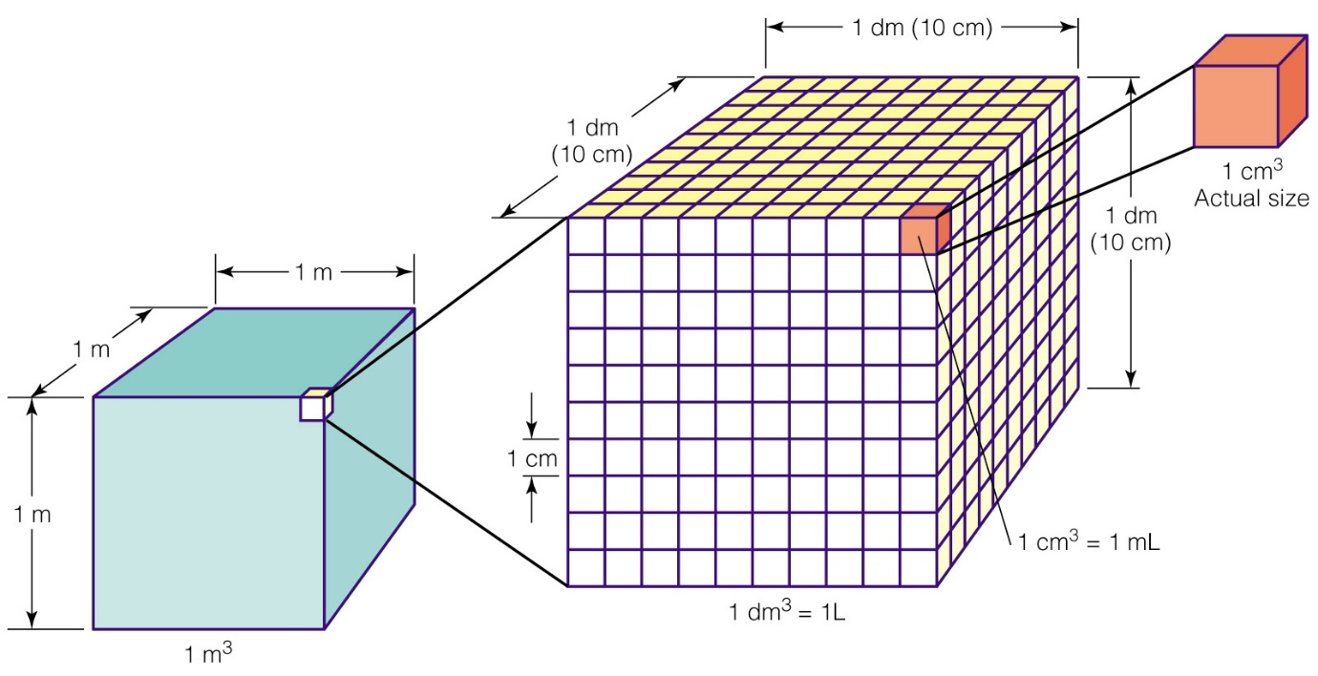

**Complete the table by converting between cm3, dm3 and m3**

|  |  |  |
| --- | --- | --- |
| **cm3** | **dm3** | **m3** |
| **1000000** | **1000** | **1** |
| **50** |  |  |
|  | **1** |  |
|  |  | **0.0034** |
|  | **0.5** |  |
| **25** |  |  |
| **670** |  |  |

1. Convert the following volumes;
   1. 12.2 cm3 into dm3
   2. 0.015 cm3 into dm3
   3. 132 dm3 into cm3
   4. 0.054 dm3 into cm3
   5. 25 dm3 into m3
   6. 0.48 m3 into dm3
   7. 25 cm3 into m3
   8. 381 m3 into cm3

2) Which is bigger?

1. What temperature is 0 oC in K?
2. What temperature is 1000 K in oC?
3. How many kg is 5 g?
4. How many m3 is 14 dm3
5. Order these from largest to smallest: 700 cm3, 0.06 dm3, 6.4 x 10-4 m3
6. Order these from largest to smallest: 18 kg, 1.8 x 105 g, 1.8 x 10-4 g, 1.8 x 102 kg

**Measuring chemicals – the mole**

From this point on you need to be using an A level periodic table, not a GCSE one you can view one here:

<https://www.ocr.org.uk/Images/363792-unit-h032-and-h432-data-sheet.pdf>

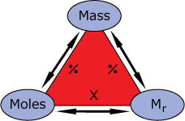The mole is the chemists equivalent of a dozen, atoms are so small that we cannot count them out individually, instead we weigh out chemicals. The standard unit for measuring is the mole. The mass number on the periodic table shows the mass of 1 mole of each element. We can refer to this as the Mr, or the relative molecular mass.

For example: magnesium + sulfur 🡪 magnesium sulphide

Mg + S 🡪 MgS

We can see that one atom of magnesium will react with one atom of sulfur, if we had to weigh out the atoms we need to know how heavy each atom is.

From the periodic table: Mg = 24.3 and S = 32.1

If I weigh out exactly 24.3g of magnesium this will be 1 mole of magnesium, if we counted how many atoms were present in this mass it would be a huge number (6.02 x 1023!!!!), if I weigh out 32.1g of sulfur then I would have 1 mole of sulfur atoms.

So 24.3g of Mg will react precisely with 32.1g of sulfur, and will make 56.4g of magnesium sulfide. The Mr of magnesium sulfide is 56.4g. This is the mass of 1 mole of magnesium sulfide. There are 6.02 x 1023 molecules in 56.4g of magnesium sulfide.

Here is a comprehensive page on measuring moles, there are a number of descriptions, videos and practice problems.

You will find the first 6 tutorials of most use here, and problem sets 1 to 3.

<http://bit.ly/pixlchem9>

<http://www.chemteam.info/Mole/Mole.html>

**Answer the following questions on moles.**

Q1 Arrange the terms mole, Mr and mass into 3 equations so each one is the subject. Use the triangle above for help.

Q2

a) How many moles of phosphorus pentoxide (P4O10) are in 85.2g?

b) How many moles of potassium in 73.56g of potassium chlorate (V) (KClO3)?

c) How many moles of water are in 249.6g of hydrated copper sulfate(VI) (CuSO4.5H2O)? For this one, you need to be aware the dot followed by 5H2O means that the molecule comes with 5 water molecules so these have to be counted in as part of the molecules mass.

d) What is the mass of 0.125 moles of tin sulfate (SnSO4)?

e) If I have 2.4g of magnesium, how many g of oxygen (O2) will I need to react completely with the magnesium? 2Mg +O2 🡪MgO

**Measuring chemicals - Solutions and concentrations**

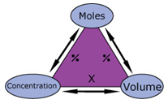In chemistry a lot of the reactions we carry out involve mixing solutions rather than solids, gases or liquids.

You will have used bottles of acids in science that have labels saying ‘Hydrochloric acid 1M’, this is a solution of hydrochloric acid where 1 mole of HCl, hydrogen chloride (a gas) has been dissolved in 1dm3of water.

The dm3 is a cubic decimetre, it is actually 1 litre, but from this point on as an A level chemist you will use the dm3 as your volume measurement. 1 dm3 = 1000 cm3



<http://bit.ly/pixlchem10>

<http://www.docbrown.info/page04/4_73calcs11msc.htm>

**Concentration**

The concentration of a solution is defined in units of moles per cubic decimetre (mol/dm3). Since 1/dm3 can also be represented as dm-3 the unit of concentration can also be represented by mol dm-3.

By looking at the units of concentration of mol dm-3 we can see that the equation for determining the concentration of a solution must be;

Concentration (mol dm-3) = no. of moles (mol)

volume (dm3)

When calculating the concentration of a solution the volume must be given in units of dm3. Therefore we need to be able to readily convert between units of m3, dm3 and cm3 in order to correctly give the concentration of a solution. The diagram below shows how to do this.

**Worked example**

**Question**

Determine the concentration of a solution in which 0.0158 mol of sodium chloride is dissolved in 25 cm3 of water.

**Answer**

*Step <1>*

Change the volume to dm3 by dividing by 1000:

25 cm3 = 0.025 dm3

*Step <2>*

Substitute the values into the equation remembering to use the units to help;

Concentration (mol/dm3) = 0.0158 mol

0.025 dm3

= 0.632 mol dm-3

= 0.63 mol dm-3 (to 2 sig. fig)

Remember you can only give your final answer to the same degree of accuracy (significant figures) as the least accurate value used in the calculation. In this case to two significant figures.

1. Give the concentrations of the following aqueous solutions in mol dm-3.

Give all final answers to an appropriate degree of accuracy.

* 1. 2.46 mol dissolved in 2.50 dm3
  2. 0.00500 mol dissolved in 24.6 cm3
  3. 1.5 mol dissolved in 0.020 cm3
  4. 63.2 mol dissolved in 2.00 m3
  5. 0.021 mol dissolved in 4.5 × 10-3 m3
  6. 81.9 g of calcium carbonate, CaCO3 dissolved in 34.1 cm3
  7. 23.4 g of hydrated copper sulfate, CuSO4•5H2O dissolved in 2.5 dm3

1. Calculate the following. Give all final answers to an appropriate degree of accuracy.
   1. The number of moles of substance in;

i. 0.025 dm3 of a 0.100 mol dm-3 solution,

ii. 24.3 cm3 of a 0.150 mol dm-3 solution

iii. 1.8 × 10-3 m3 of a 1.28 mol dm-3 solution

* 1. The mass of solid in each of the following solutions;

i. 0.0186 dm3 of a 0.012 mol dm-3 solution of NaOH

ii. 36.3 cm3 of a 4.21 mol dm-3 solution of Ca(OH)2

iii. 1.23 × 10-3 m3 of a 0.254 mol dm-3 solution of NaHCO3.

3. a) Arrange the terms Moles, Concentration and Volume into 3 equations so each term is the subject.

b) For these questions you will need to combine mass and concentration equations. If these are too tricky at the moment go back to the examples and problems in the link above, then come back to them.

1. What is the concentration (in mol dm-3) of 9.53g of magnesium chloride (MgCl2) dissolved in 100cm3 of water?
2. What is the concentration (in mol dm-3) of 13.248g of lead nitrate (Pb(NO3)2) dissolved in 2dm3 of water?
3. If I add 100cm3 of 1.00 mol dm3 HCl to 1.9dm3 of water, what is the molarity of the new solution?
4. What mass of silver is present in 100cm3 of 1moldm-3 silver nitrate (AgNO3)?
5. The Dead Sea, between Jordan and Israel, contains 0.0526 moldm-3 of Bromide ions (Br-), what mass of bromine is in 1dm3 of Dead Sea water?

**Answers to Part One**

**Standard form and significant figures**

**1** **a)** i. 2.3 × 10-3 ii. 1.032 × 103 iii. 2.75 × 106 iv. 5.28 × 10-4

**b)** i. 2010 ii. 0.052 iii. 841 iv. 0.0001

**c)** i. 1.43 × 1024 ii. 5.16 × 10-3 iii. 1.50 × 1024

**2** **a)** 4.7

**b)** 508000

**c)** 810000

**d)** 6.35

**e)** 7840

**f)** 0.00732

**3** **a)** 9.73 × 102

**b)** 6.980 × 103

**c)** 2 × 102

**d)** 4.00 × 10-6

**Converting units**

**1** **a)** 0.0122 dm3

**b)** 0.000015 dm3or 1.5× 10-5 dm3

**c)** 132000 cm3

**d)** 54 cm3

**e)** 0.025 m3

**f)** 480 dm3

**g)** 0.000025 or 2.5 × 10-5 m3

**h)** 381000000 cm3 or 3.81× 108 cm3

2. Which is bigger?

1. 273 K
2. 727 oC?
3. 5 x 10-3‑
4. 0.014 m3
5. 700 cm3 > 6.4 x 10-4 m3 >0.06 dm3,
6. 1.8 x 102 kg = 1.8 x 105 g > 18 kg > 1.8 x 10-4 g,

**Measuring chemicals – the mole**

**1.** mole = mass / Mr Mr = mass / mole mass = mole x Mr

**2**. a) 85.2/284 = 0.3 moles b) 73.56/122.6 = 0.6 moles c) 249.5/249.5 = 1.0 moles d) 0.125 x 212.8 = 26.6g

e) 2Mg : 2O or 1:1 ratio 2.4g of Mg = 0.1moles so we need 0.1 moles of oxygen (O2): 0.1 x 32 = 3.2g

**Measuring chemicals - Solutions and concentration**

**1** **a)** 2.46 mol / 2.50 dm3 = 0.984 mol dm-3 (to 3 sig. fig.)

**b)** 24.6 cm3 = 0.0246 dm3 ;0.005 mol / 0.0246 dm3 = 0.203 mol dm-3 (to 3 sig. fig.)

**c)** 0.02 cm3 = 2 × 10-5 dm3 ; 1.5 mol / 2 × 10-5 dm3 = 75000 mol dm-3 (to 2 sig. fig.)

**d)** 2 m3 = 2000 dm3 ; 63.2 mol / 2000 dm3 = 0.0316 mol dm-3 (to 3 sig. fig.)

**e)** 4.5 × 10-3 m3 = 4.5 dm3 ; 0.021 mol / 4.5 dm3 = 0.0047 mol dm-3 (to 2 sig. fig.)

**f)** 81.9 g / 100.1 g mol-1 = 0.818 mol; 34.1 cm3 = 0.0341 dm3 ; 0.818 mol / 0.0341 dm3 = 24.0 mol dm-3 (to 3 sig. fig.)

**h)** 23.4 g / 249.6 g mol-1 = 0.0938 mol; 0.0938 mol / 2.5 dm3 = 0.038 mol dm-3 (to 2 sig. fig.)

**2** **a)** i. 0.025 dm3 × 0.100 mol dm-3 = 0.0025 mol

ii. 24.3 cm3 = 0.0243 dm3; 0.0243 dm3 × 0.150 mol dm-3 = 3.65 × 10-3 mol (to 3 sig. fig.)

iii. 1.8 × 10-3 m3 = 1.8 dm3; 1.8 dm3 × 1.28 mol dm-3 = 2.3 mol dm-3 (to 2 sig. fig.)

**b)** i. 0.0186 dm3 × 0.012 mol dm-3 = 2.23 × 10-4 mol; 2.23 × 10-4 mol × 40.0 g mol-1 = 8.9 × 10-3 g (to 2 sig. fig.)

ii. 36.3 cm3 = 0.0363 dm3; 0.0363 dm3 × 4.21 mol dm-3 = 0.153 mol; 0.153 mol × 74.1 g mol-1 = 11.3 g (to 3 sig. fig.)

iii. 1.23 × 10-3 m3 = 1.23 dm3; 1.23 dm3 × 0.254 mol dm-3 = 0.312 mol; 0.312 mol × 84.0 g mol-1 = 26.2 g (to 3 sig. fig.)

**3**.a) Concentration = mole / volume Volume = moles / concentration moles = concentration x volume

**b)** i) 9.53g/95.3 = 0.1 moles, in 100cm3 or 0.1dm3 in 1dm3 0.1moles/0.1dm3 = 1.0 mol dm-3

ii) 13.284g/331.2 = 0.04 moles, in 2dm3 in 1dm3 0.04moles /2dm3 = 0.02 mol dm-3

iii) 100cm3  of 0.1 mol dm-3 = 0.01 moles added to a total volume of 2 dm3 = 0.01moles/2dm3 = 0.005 mol dm-3

iv) in 1dm3 of 1 mol dm-3 silver nitrate, 1 mole of Ag = 107.9g in 0.1dm3 = 107.9 x 0.1 = 10.79g

v) 0.0526 x 79.7 = 42.0274g

**Part Two – Skills for Practical Chemistry**

**Tables**

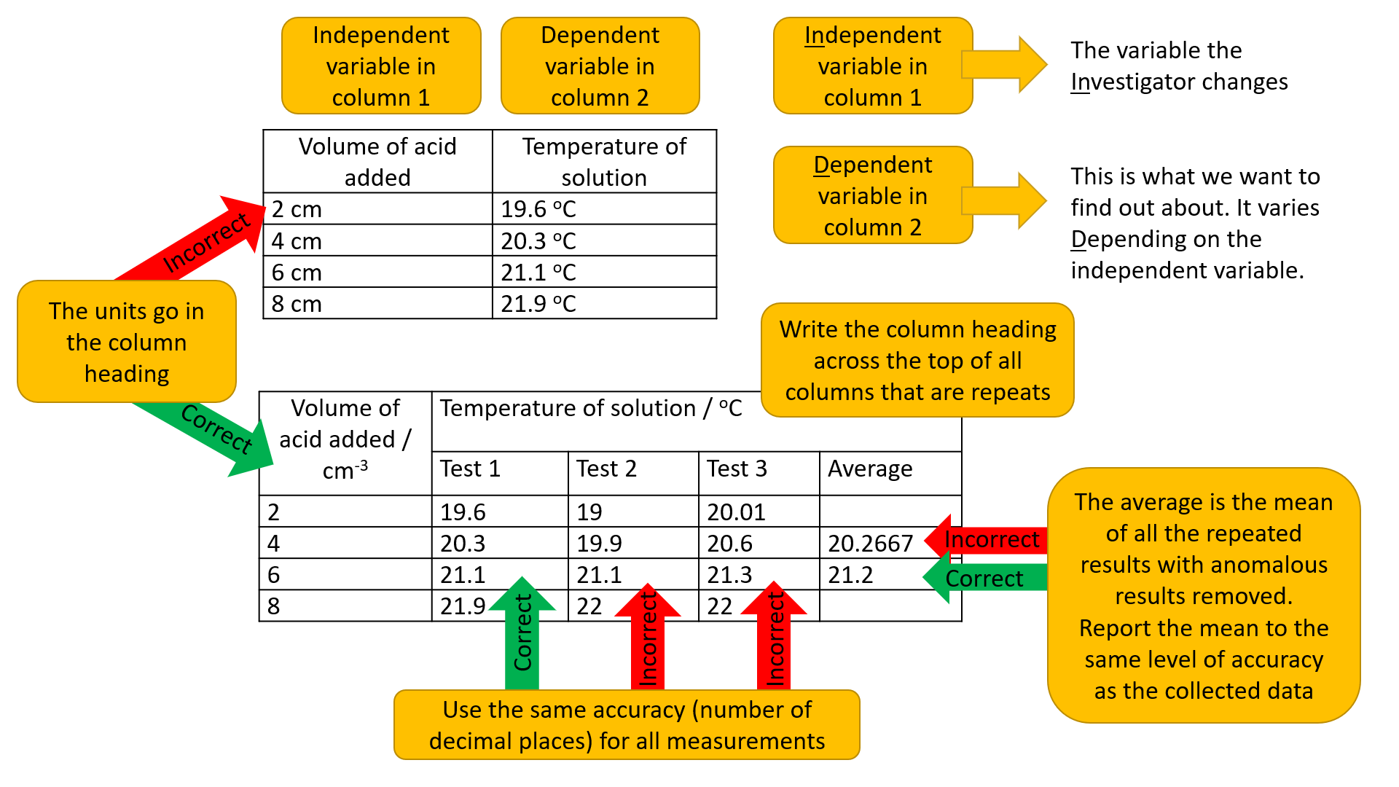

Below are three situations in which data is used to find an answer to a research question. For each situation:

1. Write the research question
2. Identify the Independent variable
3. Identify the Dependent variable
4. List as many Control variables as possible
5. Determine if the results will be qualitative or quantitative
6. Draw a table for the results, include suitable headings with units (if appropriate)

1, Emilia was making strawberry jam. She tried four different recipes each with a different ratio of sugar to fruit to see which consistency she preferred.

2, Traffic management scientists were measuring the speed of cars to find if the time of day was a factor in speeding.

3, How does the volume of acid added to an alkali affect the pH?

Submit your response to this task

The A level chemistry course has 12 Required Practicals. They are used to develop your skills in handling equipment, making accurate measurements, developing a method, communication of data and minimising risk. You will carry out this one, Qualitative tests for anions, in Year 12.

Five solutions contain the following anions. Sulfate ion, SO42-, carbonate ion, CO22-, Chloride, Cl-, Bromide, Br-, and Iodide, I-.

1. Describe how to test for and identify each anion. Use the links below to help.
2. List every chemical required. Include the reagents and the solutions to be tested.

Qualitative tests were carried out. The results were: solution 1,2 and 4 had no reaction with hydrochloric acid, solutions 3 and 5 effervesced. Solutions 1,2 and 4 formed precipitates with silver nitrate solution. The colours of the precipitates for solutions 2 and 4 were difficult to distinguish between, the precipitate of solution 1 was white. Solution 3 also formed a white precipitate when reacted with barium chloride.

1. Draw and complete a table for these results. Include the identity of each anion.
2. Identify the advantages of a table over the prose format above. The results provide a response to the question “What is found in the research performed?”.

CGSE refresher of how to test for carbonate ions, sulfate ions and halide ions. <https://www.youtube.com/watch?v=mWTgHjdea4Y>

A level - how to distinguish between halide ions <https://www.chemguide.co.uk/inorganic/group7/testing.html>

A level – how to distinguish between halide ions <https://www.youtube.com/watch?v=__96chpEILg>

A level - how to test for anions <https://www.youtube.com/watch?v=CwHjlgDqXNA>

Answers – Part 2

1. Write the research question
2. Identify the Independent variable
3. Identify the Dependent variable
4. List as many Control variables as possible
5. Determine if the results will be qualitative or quantitative
6. Draw a table for the results, include suitable headings with units (if appropriate)

1, Emilia was making strawberry jam. She tried four different recipes each with a different ratio of sugar to fruit to see which consistency she preferred.

Which strawberry jam recipe do I prefer?

IV – ratio of sugar to fruit

DV – consistency of jam

CV – type of fruit, ratio of other ingredients, length of time to cook, temperature of heat applied

Qualitative results

|  |  |  |
| --- | --- | --- |
| Ratio of fruit to sugar as stated in recipe | Consistency | Preference rank order |
| 1 | This is descriptive, leave plenty of space. |  |
| 2 |  |  |
| 3 |  |  |
| 4 |  |  |

2, Council management scientists were measuring the speed of cars to find if the time of day was a factor in speeding.

Does time of day affect traffic speed?

IV – time

DV – speed

CV – location, amount of warning drivers have about the speed check, type of warning drivers have about the speed check

Quantitative results

|  |  |  |
| --- | --- | --- |
| Time | Speed mph or ms-1 | Average speed |
| The smaller the time intervals the more precise the data. | This needs to measure multiple vehicles so will have multiple columns under the same heading |  |
|  |  |  |
|  |  |  |
|  |  |  |

3, How does the volume of acid added to an alkali affect the pH?

How does the volume of acid added to an alkali affect the pH?

IV – volume of acid added

DV – pH

CV – concentration of acid, concentration of alkali, type of acid, type of alkali

Quantitative results

|  |  |
| --- | --- |
| Volume of acid added / cm3 | pH |
|  |  |
|  |  |
|  |  |
|  |  |
|  |  |

**Part 3: Research activities**

Submit your response to this task

Choose task 1 and at least one other task from the list of topics below. Use your online searching abilities to find out as much about the topic as you can. Remember you are a prospective A level chemist so you should aim to push your knowledge. Present your information as Cornell notes with references. You will be marked on your research and referencing as part of the 12 Required Practicals in the A level course. Now is a good time to get to grips with how to reference accurately and quickly.

How to make Cornell notes: <https://www.youtube.com/watch?v=lsR-10piMp4>

How to reference: <https://www.google.com/search?q=how+to+reference&rlz=1C1SQJL_enGB797GB817&oq=how+to+reference&aqs=chrome..69i57j0j69i59j0l5.2666j0j7&sourceid=chrome&ie=UTF-8#kpvalbx=_CBS_XsyEN4PwxgOa6LDACw51>

**You can make a 1-page summary for each one you research using Cornell notes:**

http://coe.jmu.edu/learningtoolbox/cornellnotes.html

**You must choose this: Task 1: Development of the atomic model** What were the major ideas about atoms that led to the current model of the atom? Who were the Scientists involved? How was new information found? How were new information and ideas shared and reviewed?

**Choose at least one from the rest of the list:**

**Task 2: Why is copper sulphate blue?**

Copper compounds like many of the transition metal compounds have got vivid and distinctive colours – but why?

**Task 3: Aspirin**

What was the history of the discovery of aspirin, how do we manufacture aspirin in a modern chemical process?

**Task 4: The hole in the ozone layer**

Why did we get a hole in the ozone layer? What chemicals were responsible for it? Why were we producing so many of these chemicals? What is the chemistry behind the ozone destruction?

**Task 5: ITO and the future of touch screen devices**

ITO – indium tin oxide is the main component of touch screen in phones and tablets. The element indium is a rare element and we are rapidly running out of it. Chemists are desperately trying to find a more readily available replacement for it. What advances have chemists made in finding a replacement for it?

**Task 6: The chemistry of fireworks**

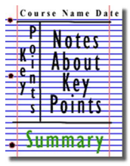What are the component parts of fireworks? What chemical compounds cause fireworks to explode? What chemical compounds are responsible for the colour of fireworks?

Figure 1: http://coe.jmu.edu/learningtoolbox/images/noteb4.gif

**Part 4 – Minimising risk**

Part of being a good scientist is staying safe! Some of the chemicals you will use in your Chemistry course can be dangerous if handled carelessly, or mixed incorrectly.

The Consortium of Local Education Authorities for the Provision of Science Services (CLEAPPS) provide information for practical science to schools in many forms, including Student Safety Sheets. Click here to download a copy <https://www.yumpu.com/en/document/read/22294738/student-safety-sheets-cleapss>

You will use these sheets to find information about the chemicals and methods you will use during your A level study. Before completing any practical work in lessons, either you, your teacher or the Science Technicians, will complete a risk assessment. This identifies the possible dangers and identifies ways to minimise the dangers to an acceptable, safe level.

* Each chemical has its own entry in the risk assessment, which includes the concentration (where known) and the appropriate response for this concentration.
* The methods used (eg, heating, use of glassware, putting gases under pressure) have their own entry in the risk assessment.
* The disposal of the chemicals and contaminated equipment is noted.

How to use the student safety sheets:

In this example I shall use silver nitrate, this is used to test for aldehydes in Tollen's reagent and to test for halogenoalkanes.

1. Use the contents page to find the chemical

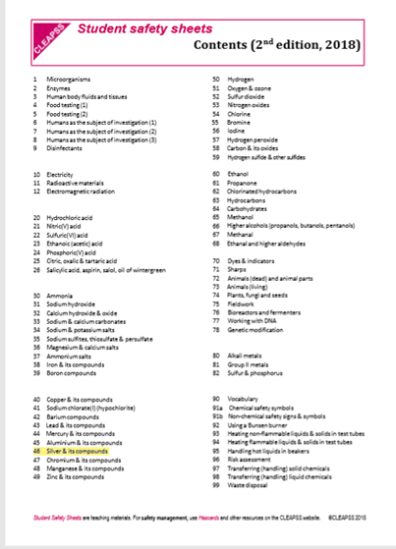

1. Silver compounds are on sheet 46.

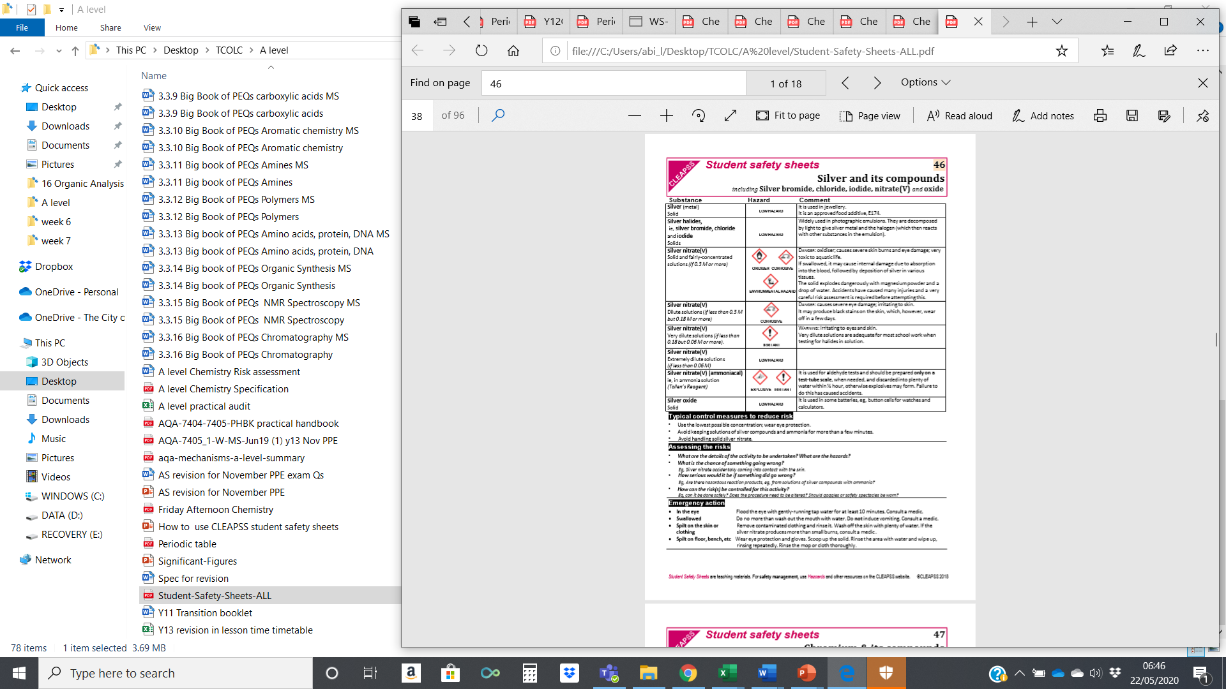

1. Sheet 46 has several silver compounds, we are looking for silver nitrate.
2. The method specified 0.1M concentration, choose the most appropriate information.

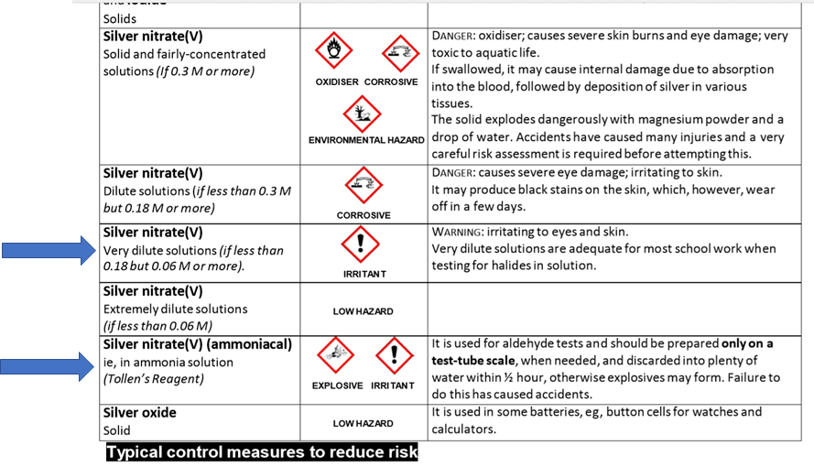

1. Take notice of the disposal information and emergency procedures. You should never need to use the emergency procedures because writing the risk assessment makes you aware of the risks, so therefore careful to avoid them!

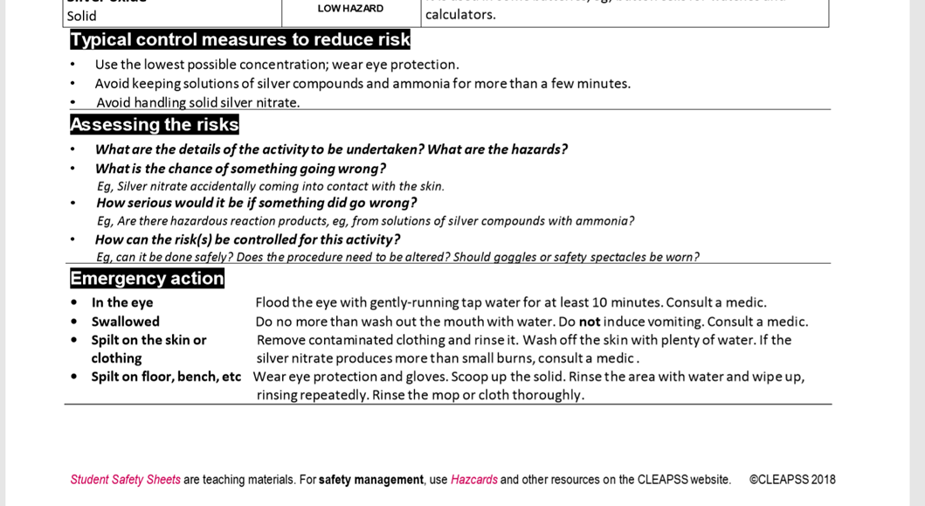

1. Complete the Risk Assessment table with information from the sheets

A level Chemistry Risk assessment

|  |  |  |  |  |
| --- | --- | --- | --- | --- |
| Title of practical: | | | | Date: |
| Outline of procedures: | | | | |
| Hazardous substance / procedure | Nature of hazard | Control measures (precautions) | Emergency action | Information sources (full url with date of access or, book title, author, publisher, date of publish and page number) |
| Silver nitrate solution (0.1M) | Irritant to eyes and skin | Wear safety glasses.  Use only in test tube quantities.  Discard of solutions within a few minutes. | In eye: Flood with gently running water for min 10 minutes. Get medical attention.  In mouth: rinse only, do not induce vomiting. Get medical attention.  On skin: wash skin. Seek medical attention if burns.  Spilt: wipe and rinse cloth thoroughly. | CLEAPSS Student safety sheets, 2nd edition, 2018. Sheet 46. |
|  |  |  |  |  |
|  |  |  |  |  |
|  |  |  |  |  |
|  |  |  |  |  |
|  |  |  |  |  |
|  |  |  |  |  |
|  |  |  |  |  |
| Disposal of residues: | | |  | Carried out by:  checked by:  Date: |

Submit your response to this task.

Complete the blank risk assessment on p19 with the chemicals required for the Qualitative Tests for Anions on page 12 of this booklet.

